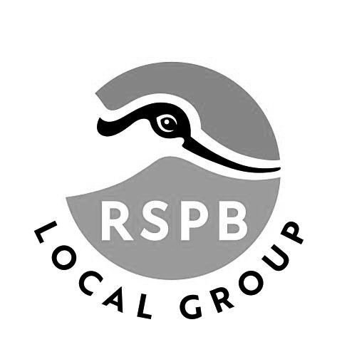**Lincoln RSPB Local Group**

**Holiday Booking Form**

The Three Counties Tour

4th-7th June 2025

**Visiting Avalon Marshes (Shapwick), Seaton Wetlands (East Devon)**

**RSPB Ham Wall, Langford Lakes (Wiltshire Wildlife Trust)**

**£350 per person in a twin or double room £395 per person in a single room**

**Deposit £50 Balance Payable by 30th April 2025**

**Includes all coach transport from and to Lincoln and between the hotel and the reserves, three nights dinner, bed and breakfast at the Shrubbery Hotel, Ilminster,**

**a Day Rover ticket on the Seaton Tramway and driver’s gratuity.**

**Name(s):___________________________________________________________**

**Address: ___________________________________________________________**

**Email:___________________________Phone_____________________________**

**Room required: Double / Twin / Single (delete as appropriate)**

**Emergency contact name and phone number**

**__________________________________________________________________**

**Complete the booking form and email to** [**holidays@lincolnrspb.org.uk**](mailto:holidays@lincolnrspb.org.uk)

**Payment by BACS (preferred)**

| **Account Name** | **RSPB Lincoln Holidays** |
| --- | --- |
| **Account Type** | **Business Account** |
| **Account Number** | **36613960** |
| **Sort Code** | **30-96-26** |

**Payment by Cheque**

**Send your cheque and booking form to:**

**Graham Mumby-Croft, 15 Thirsk Drive, Lincoln LN6 8SZ**

**Please note that deposits are non-refundable unless the place is re-sold or the event is cancelled, in which case a full refund will be made**

**PICKUP POINT**

**Please indicate your preferred pickup point:**

**Hykeham Railway Station________________**

**Lidl / The Forum________________________**

**Newark Road, The Plough________________**

**Lincoln Railway Station__________________**

**Parking is available at Hykeham Railway Station in the first section of the car park, NOT in the fenced car park next to the station itself.**

**INSURANCE**

As this trip includes overnight accommodation it cannot be classed as a charitable event, which means that neither the RSPB nor the Lincoln RSPB Local Group can provide any form of travel insurance. Once the balance has been paid, refunds will only be made for the accommodation cost and then only if the hotel makes a refund or we are able to book a replacement participant.

**For this reason, it is strongly recommended that you take out a travel insurance policy**.

The RSPB cannot endorse or recommend a specific travel insurance policy so you are advised to speak to an insurance broker or search online for an insurance policy to meet your requirements.

DATA PROTECTION

Your data will be held by Lincoln RSPB Local Group until the trip has been completed. It will be not be used for any other purpose except for contacting you about this trip.